DIVERSITY COMMITTEE

AGENDA

**Honoring Place.** The University of Washington acknowledges the Coast Salish peoples of this land, the land which touches the shared waters of all tribes and bands within the Suquamish, Tulalip and Muckleshoot nations.



Date: 04/19/2021

Time: 2:30-4:00 PM

Zoom: <https://washington.zoom.us/j/97371003914?pwd=K1Y5bTRBeEs3WmM4alBNTFovdnJPdz09>



**Diversity Committee Norms**

**Stay engaged; Speak your truth; Experience discomfort; Expect & accept non-closure; Listen for understanding; No ‘fixing’; Take risks.**

**HEALS.** During this public space meeting, issues related to diversity and inclusion are discussed. Things may be said or raised by participants that unintentionally cause harm, offense, or negative impact, which calls for the need to discuss in the moment. One process to facilitate this discussion is the HEALS Model. The HEALS Model is intended to help people identify and guide emergent discussions that may cause discomfort to a member or members of the community, including in public spaces. By emergent, we mean when a comment or action raises an assumption about stereotypes or discriminates against another person or group of people. It is our collective responsibility to manage these discussions and HEALS can be an effective strategy to do this. We endorse the spirt of “calling in,” rather than “calling out,” with care and thoughtfulness, as well as ask all to come into this space with receptivity to learn and grow.

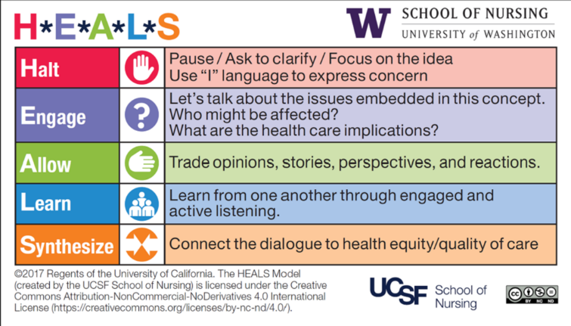

AGENDA (**RED** items indicate action needed)

|  |  |
| --- | --- |
| **Topic** | **Notes/Decision** |
| **1. Welcome**  (10 minutes) | Welcome |
| **2. Updates**  (10 minutes) | Chair: Cher Espina   * Anti-Racism Outcomes & Timeline [Link](http://dei.nursing.uw.edu/wp-content/uploads/2021/04/SoN-Antiacism-Workgroup-Outcomes-DRAFT-to-share-publicly-3.31.2020.pdf)   + Reach out to the leads if you would like to join their groups.   + These groups are meant to be temporary to jump start the school on DEI operations * SON AAPI Staff/Faculty (Asian American & Pacific Islander)   + If interested, email Cher– [sonappi@uw.edu](mailto:sonappi@uw.edu) to be added to the listserv * [UW Affinity Groups](https://www.washington.edu/diversity/staffdiv/) are available to join * Recordings for Anti-Racism Learning Day Discussion will be available at the end of April   + Dr. Danielson and Dr. Ross’s will be available   + The caucus sessions need to be edited due to discussions that are interspersed. Need to respect privacy of individuals involved. Will also check with monitors for each session. The sessions were meant for more discussion. * GO-MAP Strategies for Working through Imposter Syndrome: through Go-MAP & UW Counseling Center video available- [video](https://washington.zoom.us/rec/share/jPl-NTfFCBSfV0aINTNEQmYwBvBx8bMtG7TqWJC0ZpZXDD7BZXM0kI-o9_v5nyOl.NqiOtVrLiK3ABxHc) * Join the UW-IT Diversity, Equity & Inclusion Community of Practice for anti-AAPI hate   + Thursday, 4/22/2021 11:30am-1:00pm   + RSVP on Trumba: <https://bit.ly/2Rndqup> * Student Support also on [Student Website](https://students.nursing.uw.edu/student-services/counseling/) self care is really important   + Mental Health Wellness [Website](https://wellbeing.uw.edu/topic/mental-health/) - Mental Health Care & Counseling support have combined one website   + [My Student Support](https://myssp.app/ca/home) – 24 hour/7 days a week via app, telephone & web. Free service   + Mental Health UW   + [Let’s Talk](https://wellbeing.uw.edu/virtual-lets-talk/) Drop-In Hours, T, Th 2-4pm   + BIPOC Healing Circle –workgroup [counsels@uw.edu](mailto:counsels@uw.edu)   + PLUG-IN – for International Students quarterly meetings. Email: [yuxinsun@uw.edu](mailto:yuxinsun@uw.edu)   + Therapy Groups [Link](https://wellbeing.uw.edu/mental-health/groups-workshops-trainings/)   + Umoji   + Healing from Not Belonging |
| **3. Updates**  (5 minutes) | Chair-Elect: Brady Rainey   * Announcement for Chair-Elect nominations for AY21-22 * Can be faculty or staff; great way to get involved. * Thank you to Cher and Evie for your work * Expectations:   + Chair and student chair will work together to oversee executions of DEI task/projects, diversity committee, be a liaison to school of nursing (get blurb from Brady)   + Every 3rd Monday starting in Oct from 2:30-4   + Rebecca posted MEDIUM link [they have useful thoughts. <https://medium.com/@knit0371/making-the-transition-from-ally-to-co-conspirator-cc28a5752af7>   + Demonstrative activism -take the “act” out of activism, demonstrative vs. performative   + Be the person taking steps vs. the person who says “we should do this”. Go beyond paying lip service.   + What is seen as performative by some is seen as performative others -it is a bit of a gray area.   + Realize that though approaches differ, be willing to take value in working together.   + Look at our own power and sacrifice it in places where it needs to be more equitable.   + Culture of calling out vs. calling in. Instead ask clarifying questions and seek to understand other allies.   + Avoiding tokenism-making others responsible for the entire groups position   + Evie added and Katie will download. [Which item is this?] |
| **4. Awareness moment**  (15 minutes) | Chair-Elect: Brady Rainey  April: Performative activism. What is it? How are we enabling it?   * Pejorative term (it is surface level) * Nuanced term, encompasses a lot. * One example: If someone is empowered, but only allows others to share in the power only superficially. * Another example: Words do not match up with actions.   Future Topics  May: Colorblindness and why it is problematic. |
| **5. Updates** from Office of DEI  (25 minutes) | Associate Dean: Butch de Castro   * + Tri-campus went to upper campus and final vote will come back to Seattle. Seattle will work with Bothell/Tacoma   + Concerned that Seattle has final vote over B/T and   + Spirit of process is a collaborative language that tri-campus vote onit. Seattle would not vote until Bothell and Tacoma are on board.   + Diversity Dashboard demonstration     - Demonstrated filters, trends     - Can email Melinda Schultz with questions [schulm5@uw.edu](mailto:schulm5@uw.edu)     - This is for Seattle campus, there is a UW Profiles site for all 2 campuses. We will make public and have application data.     - Working to get this more publicly facing soon   + DNP Committee met today- intentionality to overhaul curriculum. Planning for the DNP curriculum revision and assessing where curriculum is at with DEI and revisions needed.   + Antiracism pledge workgroup presented finalized pledge statement to Executive Team   + Official handoff to office of DEI and shared council     - Optimistic that it will go through, after passing legal for policy and procedures   + Encourage to run for Diversity Committee positions * Facilitated breakout caucus discussions   + White Caucus   + POC Caucus   + Black & Indigenous Caucus   + Mixed-Race Caucus   + Guided questions:     - What are substantive actions that can be taken? What can you/we do differently?   + Create a practice where the last 15 minutes, we talk about equity issues at the end of each meeting. To create space the conversation * Follow up and discussion on all-school Anti-Racism Learning Day   + List of initiatives and actions: [The experience of the UW School of Nursing’s antiracism learning day on March 29, 2021 | Diversity, Equity & Inclusion](https://dei.nursing.uw.edu/2021/04/12/the-experience-of-the-uw-school-of-nursings-antiracism-learning-day-on-march-29-2021/) * SoN- Antiracism Work Group Outcomes document: [SoN-Antiracism-Workgroup-Outcomes-DRAFT-to-share-publicly-3.31.2020.pdf (uw.edu)](https://dei.nursing.uw.edu/wp-content/uploads/2021/04/SoN-Antiracism-Workgroup-Outcomes-DRAFT-to-share-publicly-3.31.2020.pdf) |
| **6. Share in big group**  (20 minutes) | Ideas:   * Make workgroups permanent, but update themes * Would like workshops with Dr. Ross * Establishing based on knowledge for our faculty and staff (Brady) * Thoughts on moving forward with more about ideas about events and feedback on speakers. More ideas on a thematic progression of these events, and then feedback on our speaker. More of a global picture. * There is a disconnect with leadership and concerns. Missing opportunities to create more diverse leadership. A lot of work to do within structures/hiring within the school. Adding need for blind applications for hiring and students (see Rebecca’s notes). * Creating a practice where last 10-15 min is open a space for discussion of equity issues. * <https://dei.nursing.uw.edu/dei-groups/> |
| **7. Wrap-up**  (5 minutes) | Chair-Elect: Brady Rainey  Butch-Thank you for helping plan and your engagement in this day,  Will be sending out an announcement about University Sponsored spaces when the verdict for the Derek Chauvin trial comes out. UWSoN MarCom is working with Central on statement. Forums will be announced for an opportunity for discussion  Brady -summarized meeting |

**Last Diversity Committee Meeting for the year: Monday, May 17th 2:30-4:00 pm PST**

**General Resources**

-Resa Regan (Mental Health Counselor)– [resa@uw.edu](mailto:resa@uw.edu) Available: Tues & Thurs 8am-3pm, Fridays 8am-2pm

-Hall Health - https://wellbeing.uw.edu/topic/mental-health/

-Care Link - https://hr.uw.edu/benefits/uw-carelink/

-Emergency Fund - https://students.nursing.uw.edu/financial-support/funding-sources/emergency/